PHYS 202 Ampere’s Law Name:____________________________

For any current geometry that produces a magnetic field that does not change in time,

sigma-summation Upper B Subscript double vertical bar Baseline Upper Delta Script l equals μ0Upper I

where Upper Delta Script l is a small segment of length along a closed path of arbitrary shape around the current.

1. Using Ampere’s law, show that the magnitude of the magnetic field (B) due to a long straight wire, carrying a current I, at a distance r, is given by: (μ0= 4πx10-7 T.m/A)

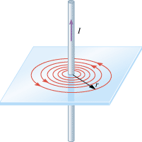

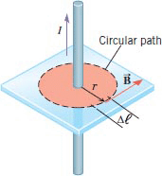

2. Describe three properties of the above magnetic field.

3. Two long straight wires, carrying currents 9.00A and 5.00A are separated by a distance of 0.120 m, lie in a plane as shown below. Determine the net magnetic field (magnitude and direction) from both currents at points A, B, and C? [C is midway between the currents]

|  |  |
| --- | --- |
|  |  |

